Practical work Javascript CSS

**Evaluated skills :**

*→ Javascript CSS lesson*

**Mini Practical Work :**

Let's face it: the exercises we did previously were still not very useful without real interaction with the user. The alert (), confirm () and prompt () is nice for a moment, but we quickly went around! It is therefore time to move on to something more interesting: a system of drag & drop! Finally ... a very simple version!

This is a mini-Practical work, which means it is not very long to achieve, but it still asks a little thought. This lab will make you use CSS events and manipulations.

**Presentation of the exercise**

First, what is drag & drop? It is a system allowing the displacement of elements by a simple displacement of mice. To put it simply, it's like when you have a file in one folder and move it to another folder by dragging it with your mouse.

And am I really able to do that?

Of course ! Well, you must have followed the course carefully and struggling a little, but it is perfectly possible, you are able!

Before boarding in the code, let's list the operating steps of a drag & drop system:

* The user presses (and does not release) the left mouse button on an item. The drag & drop is initialized then knowing that it will have to manage the displacement of this element. For information, the event to use here is mousedown.
* The user, while leaving the button of his mouse unpressed, begins to move his cursor, the targeted element then follows his movements to the trace. The event to use is mousemove and we advise you to apply it to the document element, we will explain why in the correction.
* The user releases the button of his mouse. The drag & drop then ends and the element no longer follows the mouse cursor. The event used is mouseup.

So ? It does not look so crooked, is it?

Now that you know pretty much what to do, we'll provide you with the basic HTML and CSS so you do not have to worry about doing it yourself:

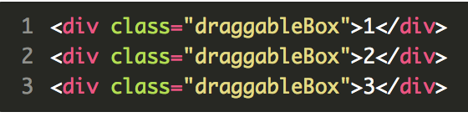

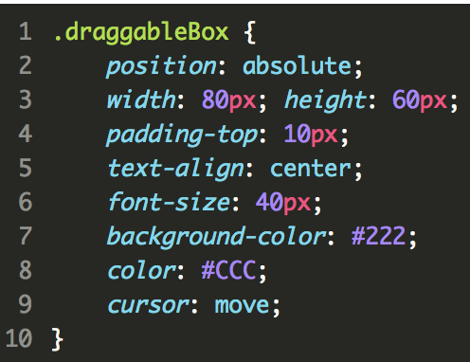

Just two last little things. It would be good :

* Whether you use an IIFE in which you will place all the functions and variables necessary for the proper functioning of your code, it will be much cleaner. Thus, your script will not pollute the global space with its own variables and functions;
* That your code does not apply to all existing <div> but only to those who own the .draggableBox class.

With that, good luck!